🔹 1. Core React Concepts (Refresher + Practical Use)
- JSX & rendering
- Component types (Functional vs. Class)
- State & props
- Event handling
- Lists & keys
- Conditional rendering
🔹 2. React Hooks (With Real-Time Scenarios)
- useState, useEffect, useRef
- useContext, useMemo, useCallback
- Custom Hooks
🔹 3. Component Architecture
- Container vs. Presentational
- Reusability & splitting logic
- Prop drilling vs. Context API
- Lifting state up
🔹 4. State Management
- Local component state
- Context API
- Redux (basics + toolkit)
- React Query (if used)
🔹 5. Performance Optimization
- Memoization (React.memo, useMemo)
- Avoiding unnecessary re-renders
- Lazy loading, Code splitting
🔹 6. Routing
- React Router (v6+)
- Nested routes, dynamic params
- Route protection
🔹 7. Forms and Validation
- Controlled vs uncontrolled components
- Formik or React Hook Form
- Yup validation
🔹 8. Testing in React
- Unit testing with Jest
- Testing Library basics
- Snapshot testing
🔹 9. Real-time Scenarios & System Design (Frontend)
- Component communication
- Design scalable components
- Error boundaries
- Handling API failures gracefully
🔹 10. Leadership-Facing Topics (for 10+ yrs experience)
- Code reviews in React
- Team guidance on best practices
- Deciding folder structure and architecture
- Migration (class to hooks, JS to TS)
- Tech decisions in UI stack
What is Library?
A collection of pre-written code that programmers can use to perform specific tasks or add functionality to a program. Libraries are often written in a specific programming language and are designed to be reusable.
What is React?
React is an open-source front-end JavaScript library also called as component based front end library that is used for building user interfaces, especially for single-page applications. It is used for handling VIEW LAYER for web and mobile applications so that its light weight application.
React helps you manage these components efficiently and keeps your UI in sync with your data.
React was created by [Jordan Walke] (https://github.com/jordwalke), a software engineer working for Facebook. React was first deployed on Facebook's News Feed in 2011 and on Instagram in 2012.
Whenever you open ecommerce website The request will hot the UI server. This server will have all static content for dynamic content it will send API server it will response for fetching the data from data server.
What are the major features of React or Purpose of React?
The major features of React are:
- It uses VirtualDOM instead of RealDOM considering that RealDOM manipulations are expensive.
what is DOM?
Document object model which represents the web page as a treelike structure which allows JavaScript to dynamically access and manipulate the content and structure of web page, we can achieve everything using Real DOM but the performance will be low.
what is virtual DOM.
When the state or props of a component change, React creates a new Virtual DOM tree and compares it with the previous one (diffing). It then performs minimal updates to the real DOM (reconciliation). This improves performance and UI responsiveness.
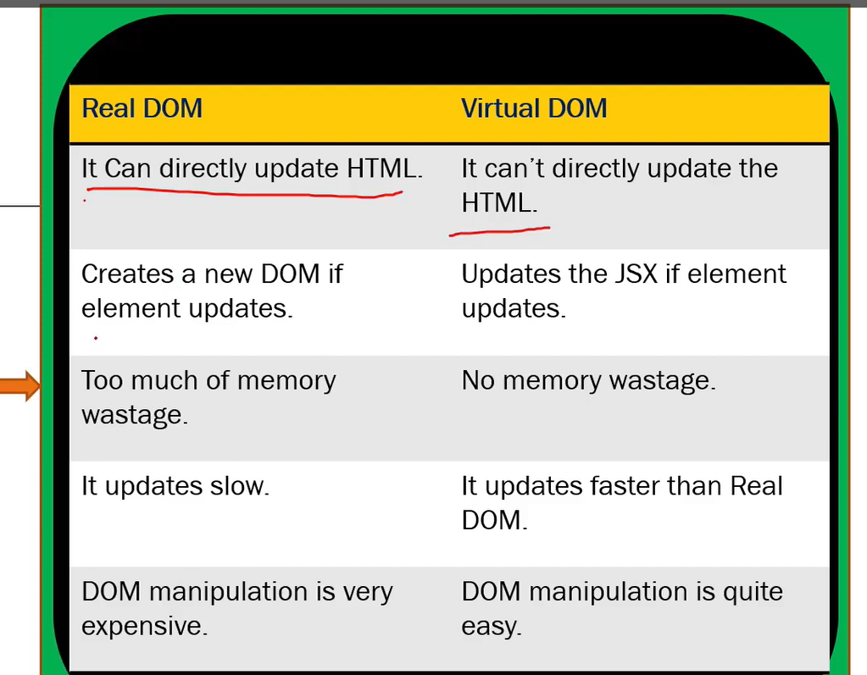

- Supports server-side rendering.
- Follows Unidirectional data flow or data binding.
- Uses reusable/composable UI components to develop the view(maintaining and scalable approach)
what is Component.?
Web consists of many parts; each part is a component.
Components are independent and reusable bits of code. They serve the same purpose as JavaScript functions, but work in isolation and return HTML.
Each components have states (interface changes) and props are objects (sharing the access with the components, its immutable we can get the data but unable to modify).
Can you explain how React’s rendering process works and how the Virtual DOM helps with performance?
React uses a Virtual DOM — a lightweight copy of the real DOM.
When state/props change, React:
- Re-renders the component in Virtual DOM.
- Diffs the new Virtual DOM with the previous one using a process called Reconciliation.
- It then batches minimal updates to the real DOM, which improves performance.
React also uses Fiber architecture (since v16) to break rendering into units of work, allowing interruptible rendering for smooth UX.
As a Tech Lead, I ensure:
- Components are pure and predictable.
- Use of React.memo, key props, and avoiding unnecessary renders.
Advantages of React.?
- Used to build sing page Application (SPA) by using components. (React follows component-based architecture which allows developer to use reusable components which can be used throughout the application and that makes its heavy speed.
- React.js is cross flatform and open-source JavaScript framework library, free to use. React is used to develop mobile and applications.
- Light weight and very fast virtual DOM. (Very fast due to Virtual dom)
- Large Community and Ecosystem.
- Testing is easy.
What is SINGLE PAGE APPLICATION.?
The web page which consists many components, if there is any change/ update in any component, only that content in the component is dynamically updated instead of refreshing the whole page.
In how many ways you can create Component ?
Components come in two types, Class components and Function components
What are the main differences between class components and functional components?
Class components use lifecycle methods (ComponentDidMount,componentDidUpdate etc.) and manage state with this.state, whereas functional components are simpler, using Hooks like useState, useEffect to manage state and side effects.
Real-time Note:
Since React 16.8, Hooks made functional components more powerful, and now most codebases—including ours—prefer function components for cleaner, testable code.
What is state and How to Update State ?
state is an object that holds or allows you to store property values that belong to the component that may change over the lifetime of a component. It is essentially the data that drives the behaviour and appearance of your component. When the state of a component changes, React re-renders the component to reflect the updated state.
- Each component can have its own state.
- The state is mutable, meaning it can change over time, usually in response to user actions or network responses.
- State is used in class components as this.state and in functional components using useState hook.
Updating State in Functional Components
- The useState hook returns an array with two elements: the current state value and a function to update it.
- Example:
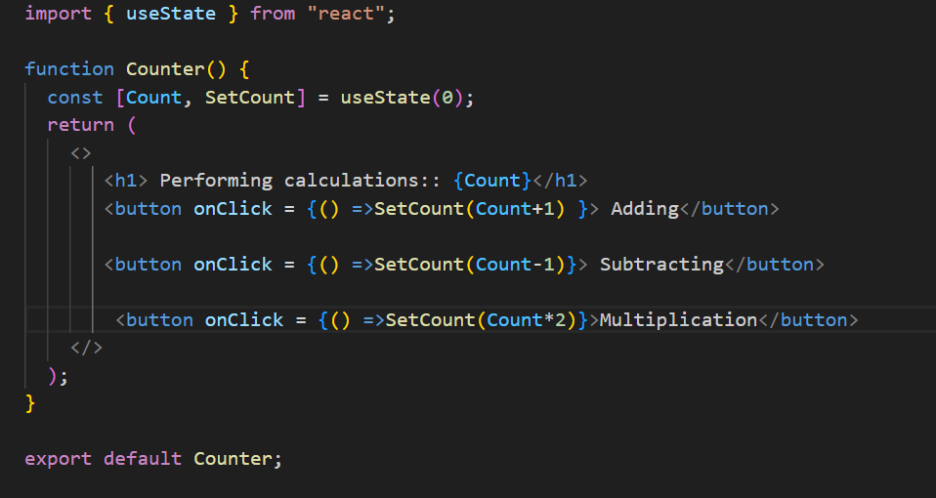- Here, `count` is the current state, and `setCount` is the function to update the state.
State management is a core concept in React, enabling you to create interactive and dynamic user interfaces.
What happens when setState() is called ?
React initiates an efficient, batched update process that eventually leads to the component being re-rendered with the updated state, ensuring that the UI stays in sync with the underlying data.
What is Props ?
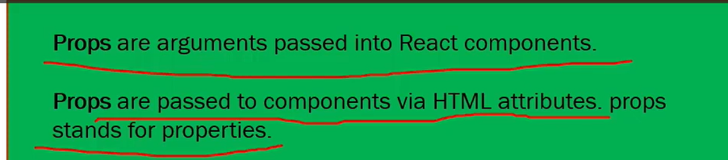
Why we use Props ?
Props allow you to pass data and behavior (via functions) from a parent component to a child component.
Hint: If you want to access a property in a child object even when the parent doesn't have that property, it will not throw an error.
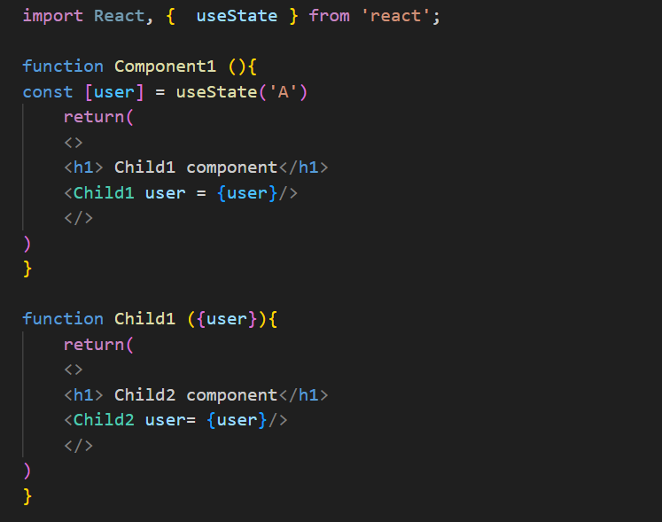
Can you explain the difference between state and props?
Props and state are both used to manage data in React, but they serve different purposes.
🔹 Props (short for "properties") are used to pass data from a parent component to a child. They are read-only from the child’s perspective, ensuring unidirectional data flow. This promotes component reusability and predictable behaviour.
🔹 State, on the other hand, is a local, mutable data container managed within the component itself using the useState (or useReducer) hook. When state updates, it triggers a re-render, allowing dynamic UI updates based on user interactions or side effects.
In short, props are for configuration, while state is for internal data that may change over the component’s lifecycle.

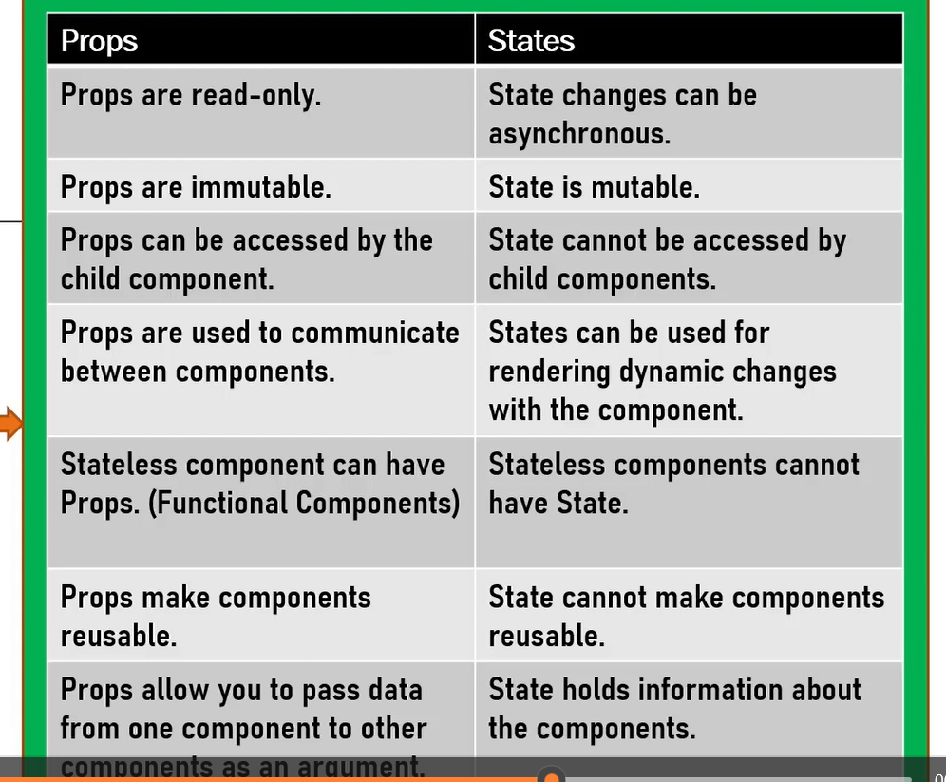
2. What happens in React when you click a button that updates state?
When I click a button that updates the state using useState, react re-renders the component with the new state value. Under the hood, React uses the Virtual DOM to compare the previous state and the new one. It then updates only the changed parts in the real DOM using a diffing algorithm, improving performance.
What are React Hooks? Which ones do you use most often?
Hooks are functions introduced in React 16.8 that let you use state and lifecycle methods in functional components.
- Simplify state management in functional components with useState.
- Perform side effects with useEffect.
- Access context values with useContext.
- Manage complex state logic with useReducer.
- Optimize performance with useMemo and useCallback.
- Access and persist values or DOM elements with useRef.
I frequently use:
- useState for managing local state
- useEffect for side effects (like fetching data)
- useRef for storing mutable values or DOM refs
- useContext for global/shared state
What is useState?

What is useEffect or How useEffect will maintain 3 lifecycle method ?
- useEffect provides a way to handle side effects in functional components.
- Replicates componentDidMount: Run useEffect with an empty dependency array.
- Replicates componentDidUpdate: Run useEffect with dependencies to react to changes.
- Replicates componentWillUnmount: Return a cleanup function from useEffect to handle cleanup logic.
What is useEffect used for?
useEffect runs side effects like API calls, subscriptions, or timers.
You can control when it runs using the dependency array:
[] → runs only once (like componentDidMount)
[dep] → runs when dep changes
no array → runs on every render
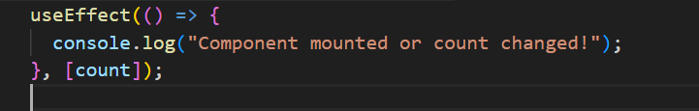
What hook runs on every render by default?
The useEffect() hook runs on every render by default, unless we provide a dependency array.
If no second parameter is given, React assumes it should run the effect after every re-render.
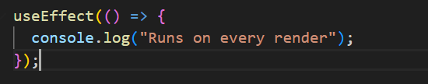
What’s the second parameter in useEffect?
The second parameter is the dependency array. It tells React when to re-run the effect:
- [] → run once on mount (like componentDidMount)
- [value] → run only when value changes
- No array → run on every render
How do you handle API calls in React?
- I use useEffect() to fetch data from APIs. I also handle loading and error states for a better user experience.
What is useRef?
useRef is used to create a mutable reference that persists across renders without causing re-renders.
Common use cases:
- Accessing DOM elements (e.g., focusing an input)
- Storing previous values
- Holding timers or interval IDs
It’s like a container that doesn’t trigger a re-render when updated.
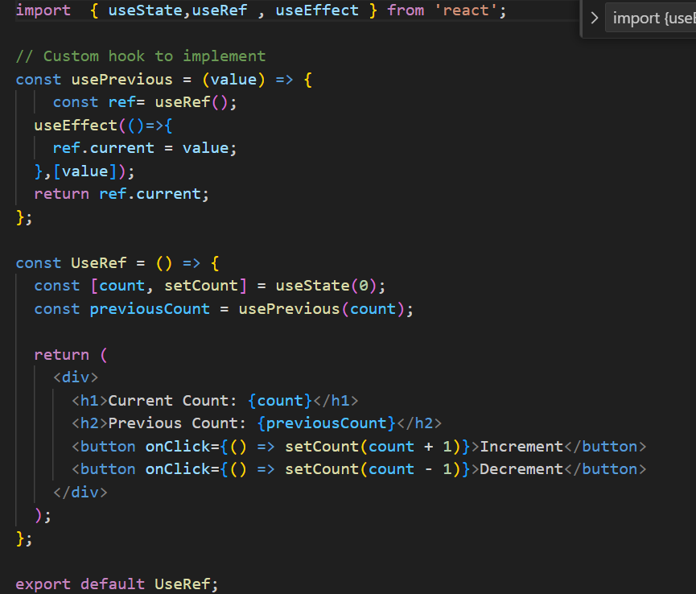
What is useMemo and when should you use it?
used to memoize the result of a computation, so it only re-computes when its dependencies change.
It helps improve performance by avoiding expensive calculations on every render.
What is useCallback?
useCallback is used to memoize functions, ensuring they're only recreated when their dependencies change.
This is particularly useful when passing callbacks to memoized child components (like those wrapped with React.memo) to prevent unnecessary re-renders caused by changing function references.
It helps improve performance in component trees where rendering logic is heavy or deeply nested.
In a large-scale UI, I’ve used useCallback to stabilize handler functions that were passed into child dropdowns or reusable lists, avoiding performance issues from repeated renders during user interactions.
What’s the difference between useCallback and useMemo?
- useCallback(fn, deps) returns a memoized function
- useMemo(() => compute, deps) returns a memoized value
Both are used to avoid unnecessary recalculations or re-creations.
How do you handle error boundaries in React?
Only class components can be used as error boundaries. You wrap components inside an Error Boundary to catch rendering errors and prevent breaking the entire app.
Error boundaries catch JavaScript errors in child components during rendering, in lifecycle methods, and in constructors. They are implemented using class components with componentDidCatch and getDerivedStateFromError.
As a lead, I recommend wrapping high-risk areas like remote data UIs and using logging services like Sentry.
What is the useContext hook and when would you use it?
useContext is a React hook that allows components to access values from a Context, eliminating the need to pass props manually through every level of the component tree.
It’s ideal for sharing global state like themes, authentication, user preferences, or language settings across multiple components.
Unlike Redux or external libraries, useContext is built into React and works best for simpler shared state where you don’t need complex logic or middleware.
In large UI apps, I’ve used useContext to manage layout preferences (e.g., dark mode, sidebar state) without overcomplicating things with Redux or prop drilling.
For more complex flows, I combine it with useReducer to maintain cleaner logic and better state transitions.

What is Context Api and Why do we use Context API ?
- Context API is a way to pass data through the component tree without having to pass props down manually at every level.
- Use Case: It's primarily used to avoid prop drilling and to manage global state that needs to be accessed by multiple components.
- Key Components: createContext, Provider, Consumer (or useContext hook).
- Advantages: Simplifies state management for certain use cases, reduces dependency on parent components, and provides a more maintainable and scalable solution for passing data across components.
Which kind problem will be solved using Context API ?
The Context API is a powerful tool for solving various problems related to state management and data sharing in React applications, including:
- Avoiding prop drilling.
- Managing global state.
- Decoupling components.
- Sharing configuration or constants.
- Handling user preferences or localization.
How do you manage global state in React?
For simple shared state, I use the Context API. If the app grows complex, I use Redux Toolkit or Zustand.
Context is great for theme, auth, or language settings.
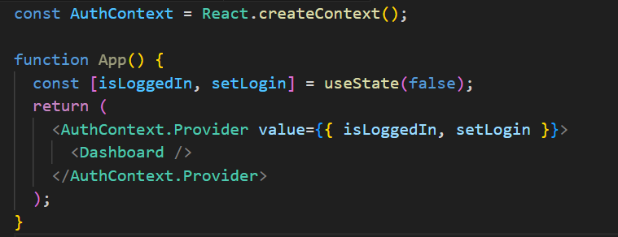

Code — Build a To-Do App using Hooks

What are controlled and uncontrolled components?
In controlled components, the form input is controlled by React state.
In uncontrolled components, the form element manages its own state using ref.
How do you optimize performance in React?
Use React.memo to prevent unnecessary renders
Split code using lazy loading and Suspense
Use proper keys in lists
Avoid anonymous functions in render
How does React handle reconciliation?
React uses the reconciliation algorithm to compare the current Virtual DOM with the previous one and applies minimal changes to the real DOM using keys and component types.

How to prevent re-render in a child component?
Use React.memo() to memoize the child component. It prevents re-render unless props actually change.

Also Avoid
Passing new inline functions or objects as props (unless wrapped in useCallback or useMemo)
Changing parent state unnecessarily

How to persist state between refreshes?
Use localStorage, sessionStorage, or even IndexedDB to persist state across refreshes.
How to create Parent Child Relation ?
Creating a parent-child relationship in React involves nesting components, where one component (the parent) renders another component (the child) and often passes data or functions as props.
What is Application Flow ?
App Initialization: The React app starts, and the root component (<App />) is rendered.
User Logs In: The user inputs credentials into a form and submits it.
State Update: The login form triggers an API call to validate the user. Upon success, the user’s data is stored in the global state.
Navigation: The user is redirected to the dashboard, where the relevant data is displayed.
Data Fetching: The dashboard component fetches additional data (e.g., user’s recent activity) and updates its state accordingly.
User Interaction: The user interacts with various elements on the dashboard, triggering updates in the UI and possibly making further API calls.
Logout: The user logs out, triggering a cleanup of user data from the state and redirecting back to the login page.
What is diff between render() in React and render() in ReactDOM ?
render() in React
- The render() method is a lifecycle method in class components that defines what the component's UI should look like.
- Purpose: It returns the JSX that represents the component's structure. This JSX is then converted to actual DOM elements by React.
- render() function from the ReactDOM library is used to render a React element (or component) into a specified DOM container on the page.
render() in ReactDOM ?
- Purpose: It serves as the entry point to rendering a React application or component tree into the DOM.
In how many ways we can pass the data from parent to child ?
- Props: The most straightforward and common way to pass data.
- Callback Functions: Allows the child to communicate back to the parent.
- Context API: Useful for avoiding prop drilling in deeply nested components.
- State Management Libraries: Ideal for complex, large-scale applications.
- Render Props: A pattern for passing data in more dynamic scenarios.
- Higher-Order Components (HOCs): A pattern for sharing logic between components.
- Composition: Passing JSX or components through the children prop for more flexible component design.
In how many ways you can manage state in React Applicatiion ?
- Local State (useState, setState): Best for managing state within individual components.
- Derived State (useMemo, useCallback): Useful for optimizing performance by memoizing expensive calculations or functions.
- Lifting State Up: Essential for sharing state between sibling components.
- Context API: Ideal for sharing state across a component tree without prop drilling.
- Redux: A powerful, widely-used global state management solution, especially in large applications.
How do you manage state in a complex React application?
For local state, I use useState or useReducer.
If multiple components share state (e.g., filters or user session), I prefer Context API for light use-cases.
For large-scale or asynchronous flows, I use Redux Toolkit — it's clean, maintainable, and handles middleware like createAsyncThunk.
As a lead, I ensure we don't overuse global state and keep components pure and reusable.
What are controlled vs uncontrolled components in React?.
A controlled component has its input value bound to React state via useState.
An uncontrolled component uses ref to access the DOM value directly.
Controlled inputs give you more control over validation and user feedback, but for file uploads or 3rd-party plugins, uncontrolled may be better.
I guide my team to stick to controlled inputs for consistency in enterprise apps.
What is axios ?
Axios is a powerful and flexible library for handling HTTP requests in JavaScript applications. Its features, such as promise-based handling, support for various HTTP methods, interceptors, and built-in error handling, make it a popular choice for making network requests and integrating with APIs in both browser and Node.js environments
Anything alternate to axios ?
Fetch API: Native, modern, and flexible; built into browsers.
jQuery AJAX: Part of jQuery; suitable if you're already using jQuery.
Superagent: Lightweight and flexible with a simple API.
Got: Advanced features for Node.js environments.
Ky: A small and elegant wrapper around Fetch.
node-fetch: Provides Fetch functionality for Node.js.
Apollo Client, Relay: Specialized for GraphQL queries and state management.

How to implement the routing the react application ?
React Router is the most commonly used library for routing in React applications.
Basic Setup: Install React Router, create components, and define routes using BrowserRouter, Routes, and Route.
Navigation: Use Link instead of traditional <a> tags for navigation.
Nested Routes: Define nested routes using Outlet.
404 Handling: Add a fallback route for handling non-existent paths.
What is Redux ?
Redux is a predictable state management library for JavaScript apps, commonly used with React.
It helps manage global state — the data that needs to be shared across many components — in a centralized and consistent way.
Why we have to use redux ?
- Helps when many components need access to the same state (e.g., authentication, theme, language, cart).
- Improves testability and debuggability.
- Useful for handling complex async flows (e.g., API calls) using Redux Thunk or Redux Saga.
What is Reducer ?
A reducer is a pure function that takes the current state and an action, and returns a new updated state — without mutating the original state.
How redux store is available to react app ?
We use the <Provider> component from the react-redux library to inject the Redux store into the React component tree.
What is redux Logger ?
Redux Logger is a middleware that logs every action dispatched and the resulting state in the console.
It is mainly used for development to help visualize:
- The action type dispatched
- The previous state
- The next state
How to call the reducer ?
You don’t call a reducer directly — instead, you dispatch an action, and Redux internally calls the corresponding reducer to update the state.
Can you explain Redux flow ? ()
Redux is a state management library commonly used with React to manage the state of applications in a predictable way. The Redux flow refers to the sequence of steps and interactions involved in managing state changes within a Redux-based application.
Action Creation: An action is created (either directly or using an action creator).
Dispatching Action: The action is dispatched to the store.
Reducer Handling: The store sends the action to the appropriate reducer.
State Update: The reducer processes the action and returns a new state.
State Change Notification: The store updates its state and notifies subscribed components or listeners.
Component Rendering: Components access the updated state (usually via mapStateToProps or hooks like useSelector) and re-render based on the new state.
How do you optimize performance in a large-scale React app?
Performance optimization involves:
- Code-splitting using dynamic import() and React.lazy
- Memoization with React.memo, useMemo, and useCallback
- Avoiding unnecessary re-renders using pure components
- Virtualizing long lists using react-window
- Debouncing and throttling user inputs
- Implementing lazy loading of routes and images
- Using Profiler API to analyze performance

Why hooks were introduced?
Hooks were introduced to:
- Simplify state management and side effects in functional components.
- Facilitate the reuse of stateful logic through custom hooks.
- Improve the readability and maintainability of components.
- Align with functional programming principles.
- Avoid issues associated with complex component hierarchies and wrapper hell.
What is the use of useContext() ?
The useContext() hook in React is used to access the value of a context in functional components. Context is a way to pass data through the component tree without having to pass props down manually at every level.
how can you create reference for element in functional Component ?

What is the diff btw useState and useReducer
Encourage useReducer for:
- Complex forms
- Nested state objects
- Undo/redo features
Use useState for:
Simple toggles
Primitive values
Quick UI flags
How to use Redux in Functional Component ?

What is the diff between functional and Class components.
Functional component | Class component
No need to import react. | Import of (react & component) must include
Normal function syntax with return () is must. | Class App extends Component is must, in order to act as react component
light weight | Extra structure is needed.
Destructing will be done by passing within args | Extra line needed for destructuring,  Method and variables
Here we cannot use life cycle methods in functional components we can handle it using HOOKS except ComponentDidCatch error boundaries. (higher level error catch). | Render () is also react lifecycle method.
 | Mounting- ComponentDidMount
 | Updating- ComponentDidUpdate
 | Unmounting- ComponentWillMount
function Heva (){  return (  <>  <p>She is playing</p>  <p>Here hobby is playing</p>  </>  )  } | Class component: Methods and  import React, { Component } from 'react';  class classComponent extends Component {  render() {  return (  <div>  </div>  );  }  }  export default class;

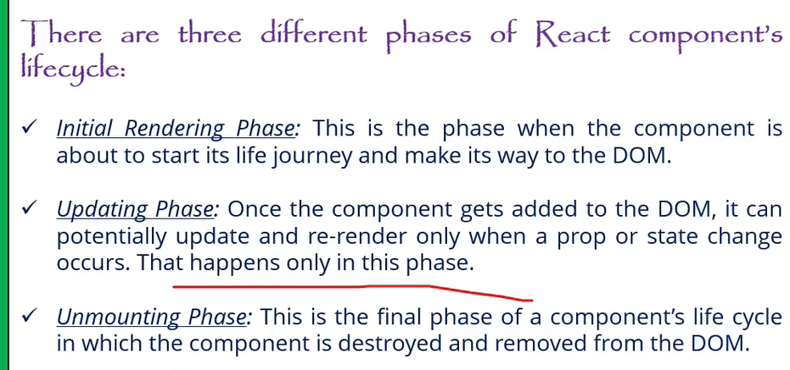
Can you explain the main differences between React class components and functional components with hooks? Why might you choose one over the other?
Lifecycle Methods in Class Components:
- **Mounting:** - `componentDidMount`: Called once the component is mounted.
- **Updating:** - `componentDidUpdate`: Called after the component updates due to changes in props or state.
- **Unmounting:** - `componentWillUnmount`: Called right before the component is unmounted and destroyed.
Note: `componentWillMount` is not recommended for use anymore due to potential issues and is considered legacy. For mounting, use `componentDidMount` instead.
2. **Functional Components with Hooks:**
- Functional components do not have lifecycle methods directly. Instead, you use hooks to achieve similar functionality:
- **`useEffect` Hook**: This hook can replicate `componentDidMount`, `componentDidUpdate`, and `componentWillUnmount` behavior. By specifying dependencies, you can control when effects run.
- **`useState` Hook**: Used for managing state in functional components, replacing the need for `this.state` and `this.setState`.

**Why Choose One Over the Other?**
- **Functional Components**: Generally preferred for their simplicity and ease of use. Hooks make it easier to share logic and manage state without worrying about the complexity of class components.
- **Class Components**: Might be used for legacy codebases or when you need specific lifecycle methods not yet covered by hooks (although hooks generally cover all use cases).

Would you like to elaborate more on this or move to the next question?
What is JSX?
*JSX* is a XML-like syntax extension to ECMAScript *JavaScript XML*. primarily used with React to describe what the UI should look like. JSX allows you to write HTML-like code within JavaScript, making it easier to create and manipulate UI components, giving us expressiveness of JavaScript along with HTML like template syntax.
JSX converts to JavaScript with help of babel transpiler, because browser understands only javascript.
Basically it just provides syntactic sugar for the `React.createElement()` function.In the example below text inside `<h1>` tag is returned as JavaScript function to the render function.
function MyFirstComponent() {
return (
< >
<h1> My First React Component! </h1>
</ >
);}
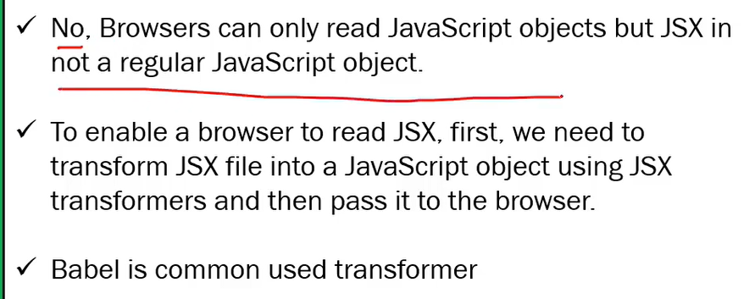

what are the main files in React.js
Minimum 6 filers are.
- Index.html file- Though single page application which is under public folder.
- Components The components which should be in application are used to place under src folder only.
- App.js Main component. or root components
- App.test.js- unit test
- Index.css- glogal css file.
- Index.js file entry point of javascript file
Why to use React over other framework?
• Performance: React excels at handling dynamic UIs with
minimal re-renders, keeping your app fast and snappy.
• Composability: React components promote code reusability,
making development faster and easier to maintain.
• JSX: JSX syntax blends JavaScript with HTML, making UI
creation intuitive for developers.

Large Community: A vast community and ecosystem provide support,
libraries, and tools for rapid development.

Arrow function expression in React.js?
Arrow function is a way of declaring the function using the arrow operator where first pass the parameters in the bracket then put the whole logic.
Difference we don’t need to add function and function name.
Assigning function itself to a variable.
React hooks
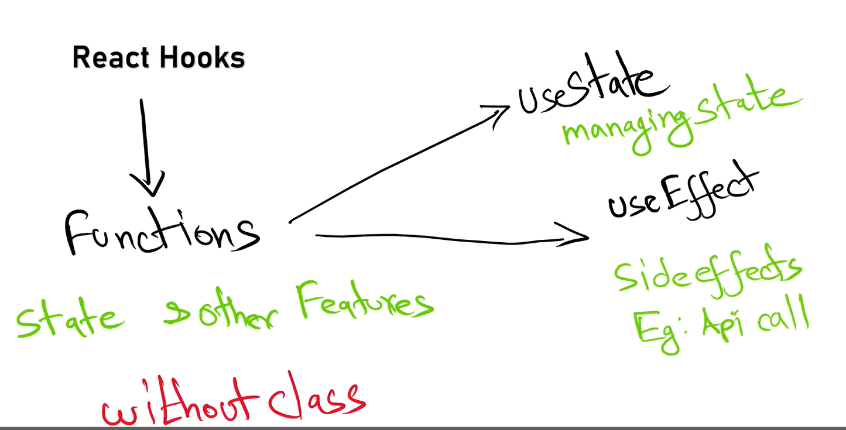
Lazyloading?
Lazy loading in React helps optimize performance by loading components or resources only when they are needed. You can use React.lazy and Suspense for components, dynamic imports for assets, and libraries like react-lazy-load-image-component for images. This technique reduces initial load time and improves user experience.
Parent to child pros?
Passing data from parent to child components in React provides benefits such as centralized data management, controlled data flow, component reusability, simplified state management, enhanced readability, encapsulation, and flexibility. This approach aligns with React’s design principles and helps build maintainable and scalable applications
what is the disadvantages of using JavaScript in reactjs?
If you developed react js using Javascript and we declare an object variable with string data type this will throw error at run time in production browser so will face type safety with javascript.
Authentication flow in React.js
Authentication Context: Use the React Context API to manage authentication state and provide it throughout your application.
Authentication Components: Create login and logout components and handle user authentication.
Protect Routes: Use a ProtectedRoute component to restrict access to certain routes based on authentication state.
Persistence: Persist authentication state using localStorage or sessionStorage.
API Integration: Implement API calls for login and manage authentication tokens as needed.
Side effects?
While the component is re-rendering the logic inside the component will execute again and again, in this case we have to isolate that particular logic using use Effect.
Can you explain useEffect with a real-time use case?
I use useEffect(() => {...}, []) to fetch data on mount.
For cleanup (like WebSockets or event listeners), I return a cleanup function:
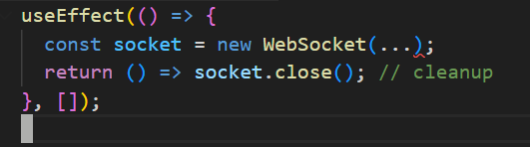
What’s the difference between useEffect, useLayoutEffect, and useInsertionEffect?
- useEffect runs after the paint. It's used for API calls, subscriptions, etc.
- useLayoutEffect runs before the browser paints — ideal for reading layout or DOM measurements.
- useInsertionEffect (introduced in React 18) runs before DOM mutations, mainly used for libraries injecting styles (e.g., Emotion).
What is Props drilling in React and how to overcome.
Passing of props to the multi-layer of components (Nested components) or is called props drilling but the properties passing may not useful for all components that is wasting of memory
Complexity increases code reusability.
Debugging becomes challenging in in order to overcome this we have use Context. Or using redux library we can avoid props drilling.
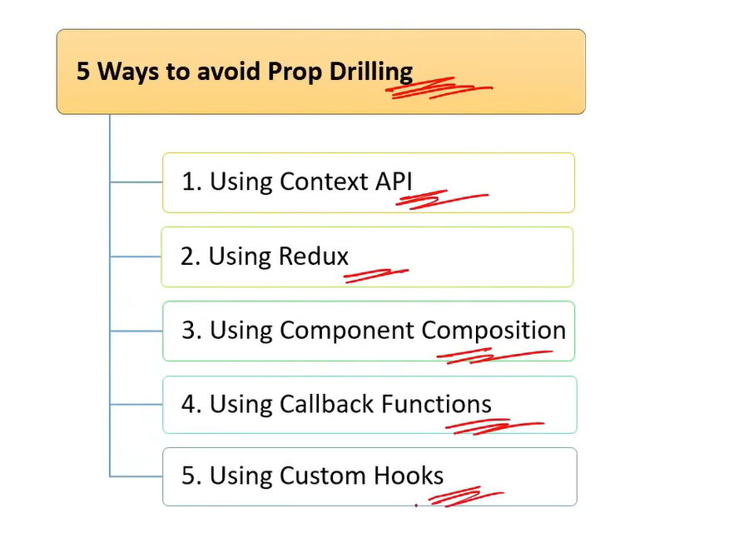
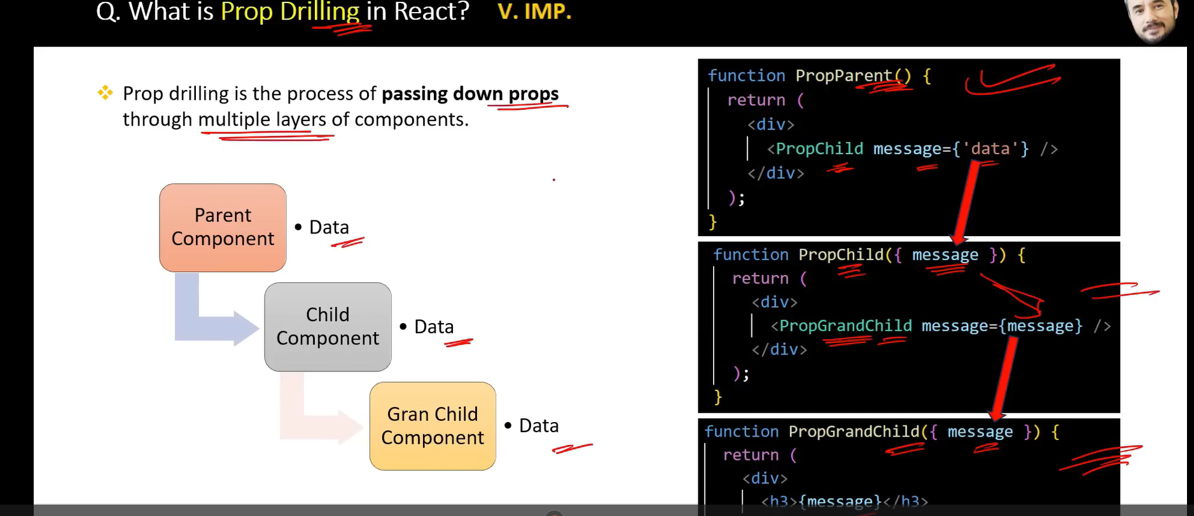
How to protect a Route.?
Protected route is used to handle the security which is avail from React router dom.
Higher order component.?
The folder and structures maintaining in React with architecture format. The application will be scalable.
Stateless and stateful components.?
Stateless Components:
- Do not manage internal state.
- Render UI based on props.
- Simpler and more focused on presentation.
Stateful Components:
- Manage internal state and lifecycle methods (class components) or side effects (functional components with hooks).
- Handle user interactions and complex operations.
- More complex and capable of managing state and side effects.
Purpose of React render Method?
The render method is crucial in React for defining the component’s UI based on its state and props. It:
- Describes the structure of the UI.
- Updates the UI when state or props change.
- Composes complex UIs using other components.
- Operates as a pure function, ensuring predictable UI updates.
Controlled and uncontrolled components?
Controlled Components:
- State Management: Form data is managed via React state.
- Predictable: The component’s state is the single source of truth.
- Event Handling: Input changes update React state.
- Advantages: Easier state management, validation, and debugging.
Uncontrolled Components:
- Ref Management: Form data is managed through the DOM.
- Less Control: React does not directly manage form data.
- Event Handling: Values are accessed directly from the DOM.
- Advantages: Less boilerplate, direct access to DOM values.
What is the purpose of keys in React lists?
Keys help React identify which items changed, are added, or removed. They optimize re-renders by giving each list item a unique identity.
Wrong Practice: Using index as a key can lead to bugs during reordering.
What is prop drilling and how can you avoid it?
Prop drilling is passing props through multiple levels of components unnecessarily. It can be avoided using Context API or state management tools like Redux or Zustand.
Example:
Instead of passing theme from App → Layout → Header → Button, we used React.createContext and useContext to directly access it inside Button.
What are Pure Components?
*`React.PureComponent`* is exactly the same as *`React.Component`* except that it handles the `shouldComponentUpdate()`, the component will re-render by default whenever `shouldComponentUpdate` is called.
a Pure Component is a component that only re-renders when its props or state change.
What is lifting stateup?
Lifting state up involves moving state management to the closest common ancestor of components that need to share the state. This pattern helps in maintaining a single source of truth, synchronizing data between components, and simplifying state management in React applications.
Dynamic Imports with React.Lazy?
- React.lazy: Allows you to load components dynamically, enabling code splitting.
- Dynamic import(): The mechanism behind React.lazy for asynchronous module loading.
- React.Suspense: Manages the loading state for components loaded lazily.
- Error Boundaries: Handle potential errors in loading components to improve user experience.

How do you structure a scalable React application?
I use a modular folder structure like:
src/
components/
pages/
hooks/
utils/
services/
store/
I encourage:
- Atomic design principles for components
- Centralized API service layer
- Environment-based config management
- Lazy-loaded routing setup
- Separation of concerns
As a lead, I emphasize code readability, maintainability, and testability.
What is Concurrent Rendering in React 18?
Concurrent rendering allows React to prepare multiple versions of the UI at the same time. It improves responsiveness and avoids UI blocking during heavy rendering. Features like automatic batching, transitions, and startTransition() help React prioritize urgent updates.
As a Tech Lead, I focus on using these APIs to ensure better user experience without performance drops.

How do you ensure code quality in a React project?
I enforce:
- Strict ESLint + Prettier rules
- Unit and integration tests using Jest, React Testing Library
- Code reviews with PR templates
- CI/CD integration for testing and linting
- Component documentation using Storybook
As a Tech Lead, I balance quality and velocity by automating checks and mentoring the team on best practices.
How do you handle SEO in a React application?
Since React is client-side rendered, SEO can be a challenge. For SEO-critical apps, I recommend:
- Server-side rendering (SSR) with Next.js
- Using React Helmet for dynamic meta tags
- Pre-rendering or static site generation where possible
- Ensuring crawlable, semantic HTML

What’s your approach to mentoring junior React developers?
I pair them with senior devs for code reviews, introduce component reuse and state management basics, and gradually give them ownership of modules. I also encourage best practices early—like meaningful naming, code comments, and testing. Regular 1:1s and shared learning sessions keep them engaged and growing.
How do you ensure code quality in your team as a Tech Lead?
- Code reviews with focus on clarity, performance, and security.
- Setup ESLint + Prettier for consistent code style.
- Maintain unit and integration test coverage.
- Automate builds, tests, and deploys using CI/CD pipelines (Jenkins/GitHub Actions).
- Encourage knowledge sharing, mentoring, and pair programming

Using React.lazy and dynamic imports effectively can help improve the performance of your React application by reducing the initial bundle size and loading components only when they are needed.

Sure! Let's dive into one of the techniques.

### Technique: Code Splitting

**Code Splitting** helps improve the performance of your React application by loading only the necessary code when it’s needed. This can reduce the initial load time of your application and improve user experience.

#### **How to Implement Code Splitting:**

1. **Dynamic Imports with React.lazy:**
- `React.lazy` allows you to load a component lazily when it’s needed.
- You wrap your lazy-loaded component in a `React.Suspense` component, which allows you to specify a fallback UI (e.g., a loading spinner) while the component is being loaded.

**Example:**
```jsx
import React, { Suspense } from 'react';

const LazyComponent = React.lazy(() => import('./LazyComponent'));

function App() {
return (
<div>
<Suspense fallback={<div>Loading...</div>}>
<LazyComponent />
</Suspense>
</div>
);
}
```

2. **Dynamic Import with React Router:**
- If you’re using React Router for navigation, you can also dynamically import route components.

**Example:**
```jsx
import React, { Suspense } from 'react';
import { BrowserRouter as Router, Route, Switch } from 'react-router-dom';

const HomePage = React.lazy(() => import('./HomePage'));
const AboutPage = React.lazy(() => import('./AboutPage'));

function App() {
return (
<Router>
<Suspense fallback={<div>Loading...</div>}>
<Switch>
<Route path="/home" component={HomePage} />
<Route path="/about" component={AboutPage} />
</Switch>
</Suspense>
</Router>
);
}
3. **Webpack Code Splitting:**
- For more advanced scenarios, you can configure Webpack to split code into separate bundles based on your application's needs. This usually involves setting up Webpack’s optimization options, like `splitChunks`.

Example Configuration (Webpack):**
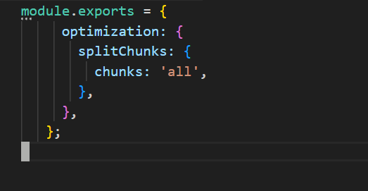
**Benefits of Code Splitting:**

- **Improved Performance:** Reduces the amount of JavaScript needed on the initial page load.
- **Faster Load Times:** Users only load the components they need, which can lead to quicker interactions.
- **Enhanced User Experience:** By deferring the loading of non-critical components, users see meaningful content faster.

FORMs?
React Forms are the components used to collect and manage the user inputs.
Events?
React Events are user interactions with the web application
Difference in ES5 ES6?
- ES5: The version before ES6, with more basic features and less syntactic sugar.
- ES6: Introduced many new features, including let, const, arrow functions, classes, modules, template literals, destructuring, default parameters, rest and spread operators, and promises.

Bundle of react?
Bundling in React involves combining JavaScript, CSS, and other assets into optimized files to enhance performance and reduce the number of HTTP requests. Tools like Webpack, Vite, and Parcel are commonly used to handle this process. Bundling not only helps in optimizing load times but also in managing and organizing code effectively.

Redux
What is Redux?
Core Concepts: Store, Action, Reducer, Dispatch
react-redux hooks: useSelector, useDispatch, Provider
Redux Toolkit (modern approach)
Smart example: Counter or Todo using Redux
Real-time scenario Q&A

